|  |  |
| --- | --- |
| **Radiocommunication Study Groups** |  |
|  |  |
|  |  |
| Received: | **Document 5D/-E** |
| **Date: 2021** |
| **English only** |
|  | **SPECTRUM ASPECTS & WRC-23 PREPARATIONS** |
| Brazil (Federative Republic of) | |
| PROPOSAL ON THE WORKING DOCUMENT TOWARDS SHARING AND COMPATIBILITY STUDIES OF IMT-2020 OPERATING IN THE 10 -10.5 GHZ UNDER WRC-23 AGENDA ITEM 1.2 | |
|  | |

Introduction

As per Resolution 811 (WRC-19), which sets out the Agenda for the 2023 World Radiocommunication Conference, Agenda Item 1.2 considers the identification of the frequency bands 3 300-3 400 MHz, 3 600-3 800 MHz, 6 425-7 025 MHz, 7 025-7 125 MHz and 10.0-10.5 GHz for International Mobile Telecommunications (IMT), including possible additional allocations to the mobile service on a primary basis, in accordance with Resolution 245 (WRC-19).

At WP 5D’s June 2021 meeting, a working document for sharing and compatibility studies of IMT systems in the frequency bands listed above was included in the Chairman’s Report.

Proposal

Brazil proposes to include this study in the working document for sharing and compatibility studies of IMT systems in the frequency band 10-10.5 GHz.

**Attachment:** 1

ATTACHMENT

WORKING DOCUMENT TOWARDS SHARING AND COMPATIBILITY STUDIES OF IMT-2020 OPERATING IN THE 10 - 10.5 FREQUENCY RANGE UNDER WRC-23 AGENDA ITEM 1.2

**Sharing studies between Active Earth exploration-satellite Service (Active EESS) in the co-channel band and IMT-2020 operating in the 10 - 10.5 GHz frequency range**

# 1 Technical Analysis

This sharing study analyses the coexistence between IMT-2020 systems and EESS (Active) operating in the co-channel band from 10 - 10.5 GHz. Technical and operation characteristics of IMT-2020 systems were based on Document 5D/716 and for EESS (Active) systems from Document 7C/45. It should be emphasized, that the antenna pattern used for EESS (Active) satellite is based on Recommendation ITU-RS 2043 Table 9, and the propagation model used were those specified in Document WP 5D/722, including Recommendation ITU-R P.619 and Recommendation ITU-R P.2108. The results were obtained through the methodology in the Recommendation ITU-R M.2101 using the simulation tool SHARC.

# 2 Methodology

The Brazilian administration continues to use and develop, in cooperation with partners in the industry and academia, an open-source simulation tool, named SHARC, to support Sharing and Compatibility studies between IMT and other radio communication systems, according to the framework proposed by Recommendation ITU-R M.2101. SHARC is a coexistence static system-level simulator using the Monte Carlo method. It has the main features required for a common system-level simulator, such as antenna beamforming, power control, resource blocks allocation, among others. The simulator is written in Python and the source code is available at GitHub https://github.com/SIMULATOR-WG/SHARC.

At each simulation snapshot, the UE is randomly generated and located within a cell cluster. The coupling loss is calculated between the UE and their nearest BS. The simulation then performs resource scheduling and power control, enabling the interference calculation among the systems. Finally, system performance indicators are collected, and this procedure is repeated for a fixed number of snapshots.

With SHARC, it is possible to study the coexistence between, IMT/HIBS and other services and applications. The main key performance indicator obtained from these simulations is the aggregate interference generated by the IMT/HIBS into the other system, and vice-versa. In this contribution, an Active EESS system is considered. The interference-to-noise ratio is calculated and compared with the SAR protection criteria for their specific frequency range.

# 2 Technical and operational characteristics used for IMT systems in the 10 – 10.5 frequency range

The IMT deployment is an outdoor Urban/suburban hotspot, considering parameters indicated in Table 1.

TABLE 1

IMT-2020 Base station characteristics

| No. | Parameter | IMT-2020 (Base station) |
| --- | --- | --- |
|  | Frequency band | 10-10.5 GHz |
| **1** | **Transmitter characteristics** |  |
| 1.1 | Duplex method | TDD |
| 1.2 | Channel bandwidth | 100 MHz |
| 1.3 | Signal bandwidth | > 90% of channel bandwidth |
| 1.4 | Antenna pattern | Recommendation ITU-R M.2101 |
| 1.5 | Antenna array | 8x8 element configuration |
| 1.6 | Element gain | 5.5 dBi |
| 1.7 | Antenna height | 6 m |
| 1.8 | Mechanical Downtilt | 100 |
| 1.9 | Base Station maximum coverage angle in the horizontal plane |  |
| 1.10 | Base Station maximum covegage angle in the vertical plane | 90 to 120 |
| 1.11 | Conducted power per antenna element | 16 dBm (power per H/V polarized element) |
| 1.12 | Spurious emission | -15 dBm / MHz |
| 1.13 | Ohmic loss | 0 dB |
| 1.14 | Polarization loss (Based on Rec. ITU-R P.619) | 3 dB |
| 1.15 | Sectors | Single sector |
| 1.16 | BS density (Ds urban) | 30 BS/km2 |
| 1.17 | BS density (Ds suburban) | 10 BS/km2 |
| 1.18 | Ra urban | 7 % |
| 1.19 | Ra suburban | 3 % |
| 1.20 | Rb urban | 1 % |
| 1.21 | Area of study | 8.510.343 km2 (1) |

1. Brazil territory area [Instituto Brasileiro de Geografia e Estatística - IBGE - https://www.ibge.gov.br/geociencias/organizacao-do-territorio/estrutura-territorial/15761-areas-dos-municipios.html]

TABLE 2

User equipment characteristics

|  | **Urban/suburban hotspot (outdoor)** |
| --- | --- |
| Indoor user terminal usage | 5% |
| Indoor user terminal penetration loss | Rec. ITU-R P.2109 |
| User equipment density for terminals that are transmitting simultaneously **(Note 1)** | 3 UEs per sector |
| UE height **(Note 2)** | 1.5 m |
| Average user terminal output power | Use transmit power control |
| Typical antenna gain for user terminals | −4 dBi |
| Body loss | 4 dB |
| UE TDD activity factor | 25% |
| **Power control model:** | |
| Maximum user terminal output power, PCMAX | 23 dBm |
| Power (dBm) target value per RB, P0_PUSCH **(Note 3)** | −95 |
| Path loss compensation factor,   (same as “balancing factor” mentioned in Rec. ITU-R M.2101) | 1 |

**Note 1:** UEs share equally the channel bandwidth, i.e. each UE is allocated 1/3 of the channel bandwidth (see Rec. ITU-R M.2101, Section 3.4.1, item 1e-f.). In sharing studies, it is assumed that the AAS BS beamforms towards each UE using the entire array.

**Note 2**: In principle, indoor UEs are distributed over different floors of the building. It should be noted that the number of floors of buildings vary within the environment and among the countries. Moreover, the number of floors of buildings is not related to Macro BS antenna height (parameter given in the Table). In particular in small cities, sub-urban and rural areas, many or most of antennas are installed on masts. Therefore, for outdoor BSs, indoor UEs are assumed to be modelled on the ground floor for the sharing study.

**Note 3**: The target power is defined per Resource Block (RB), considering 180 kHz RB bandwidth corresponding to 15 kHz subcarrier spacing.

# 2 Technical and operational characteristics used for Active EESS in the 10 – 10.4 GHz frequency range

The technical characteristics for Active EESS are based on Document 7C/45 and in the Recommendation ITU-RS. 2043-0. The characteristics are summarized in this section in Table 2.

TABLE 2

Characteristics of EESS (active) missions in 10 - 10.4 GHz band.

| Parameter | SAR-F6 |
| --- | --- |
| Sensor type | SAR |
| Type of orbit | Circular, SSO |
| Altitude (km) | 514 |
| Inclination (degrees) | 97.4 |
| Ascending node LST | 18:00 |
| Repeat period (days) | 11 |
| Antenna type | Active phased array |
| Number of beams | 1 |
| Antenna (Transmit & Receive) peak gain (dBi) | 47 |
| Polarization | Linear HH, VV |
| Azimuth scan rate (rpm) | 0 |
| Antenna beam look angle (degrees) | 18-50 |
| Antenna beam azimuth angle (degrees) | 90 |
| Antenna elev. beamwidth (degrees) [1] | 1.13 |
| Antenna az. beamwidth (degrees) [1] | 0.53 |
| RF centre frequency (MHz) | 9 800 |
| RF bandwidth (MHz) | 1 200 |
| Transmit Pk pwr (W) | 7 000 |
| Transmit Ave. pwr (W) | 2 100 |
| Pulsewidth (μs) | 50 |
| Pulse Repetition Frequency (PRF) (Hz) | 6 000 |
| Chirp rate (MHz/μs) | 24 |
| Transmit duty cycle (%) | 30 |
| System temperature (K)[1] | 500 |

[1] Recommendation ITU-R RS.2043-0

For Active EESS, it should be highlighted that the protection criteria follow recommends 2 of Rec. ITU-R RS.1166-4. Table 3 reports the protection criteria for SAR Systems.

TABLE 3

Protection criteria for SAR systems.

|  |  |  |  |  |
| --- | --- | --- | --- | --- |
| Sensor type | Interference criteria | | Data availability criteria (%) | |
| Performance degradation | *I*/*N* (dB) | Systematic | Random |
| Synthetic aperture radar | 10% degradation of standard deviation of pixel power | –6 | 99 | 95 |

Furthermore, the Active EESS antenna model is based on Rec. ITU-R RS.2043-0, Table 9. Fig. 1 reports the model used in SHARC for horizontal and vertical planes. It is important to highlight that WP 7C in a September 2021 meeting, reported that a correction factor of -1.549 dB (efficiency of 70%) along with 0.25 dB to correct the Total Integrated Directivity (TID) must be applied in the EESS Active antenna pattern.

FIGURE 1

Active EESS antenna model; (a) horizontal; (b) vertical.

|  |  |
| --- | --- |
| (a) | (b) |

Regarding the propagation models, Table 4 reports each model used and its characteristics.

TABLE 4

Propagation models for sharing and compatibility studies in the 10-10.5 GHz.

|  |  |  |
| --- | --- | --- |
| Propagation model | System | Characteristics |
| 3GPP Urban Micro (UMi) | IMT System | - |
| Rec. ITU-R P.2108 | Earth-to-space path | For every link, it is calculated the p-parameter, with a uniform distribution between [0, 1], to calculate the clutter loss, following ITU-R Rec.P.2108. |
| Rec. ITU-P P.2109 | Earth-to-space path | - |
| Rec. ITU-R P.619 | Earth-to-space path | Recommendation ITU-R P.835 is used for reference atmosphere, and a latitude < 22º (Brasilia, Brazil is at -15.8º) was considered, which has no significant seasonal variations, and thus a single annual atmosphere profile can be used. In addition, a 3 dB polarization discrimination loss was taken into account following Item 2.2 of the Rec. ITU-P.619. |

# 3 Sharing study

The sharing study has considered an Active EESS space station receiver as a victim from IMT-2020 Hotspot Base Station (BS) transmitters and User Equipment (UE). The study considered the whole satellite visibility, calculated from Attachment A of Rec. ITU-R P.619. The maximum line of sight visibility was calculated by assessing the apparent elevation angle of the Earth-space path as presented in Fig.2. For the distances above 2546 km from satellite nadir, the apparent elevation angles are below 00, the maximum satellite line of sight view, due to the heavy terrain attenuation below this limit.

FIGURE 2

Earth-to-space elevation angle as a function of distance from satellite Nadir.

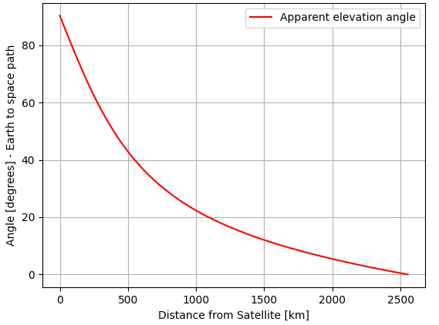

The South America satellite visibility is a view of 20,126,808 km² as presented in Fig.3 in the red circle, while Brazil's territory area, around 8,510,345.358 km2 [1]. More than 86% [2] of Brazil is comprised of forests, agricultural areas, and semiarid places, with low population density. The whole satellite visible view of the Earth for a space object operating at 514 km altitude height is represented by a spherical cap with an arc length of approximately 5,092 km. Considering that the satellite will also be covering oceans simultaneously to land surfaces, the number of Hot Spots were calculated based on the area of 8,510,345.358 km², to discount large unpopulated areas in South America inside the full visibility of the satellite, but these Hot Spots were spread over an larger area, once different countries may deploy IMT in this band. Furthermore, to illustrate our simulation scenario, Fig.4 reports the Active EESS scanning Brazil territory in two antenna beam angles.

FIGURE 3

**Representation of the whole satellite visible view over South America from Brazil territory**

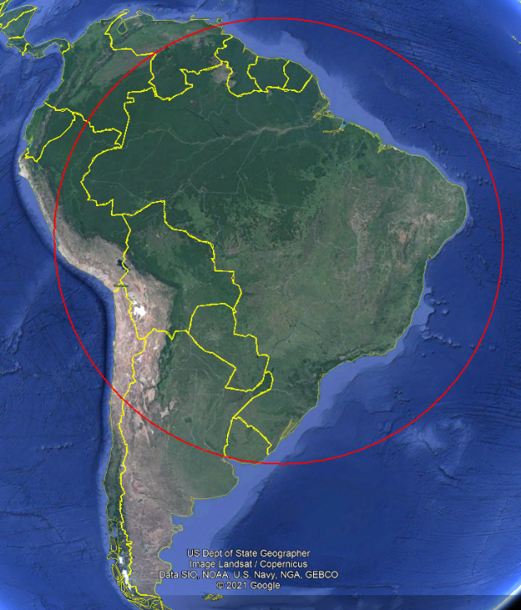

FIGURE 4

Simulation scenario covering Brazil area with Active EESS stations scanning in two antenna angles (not in scale, only for illustrative purpose)

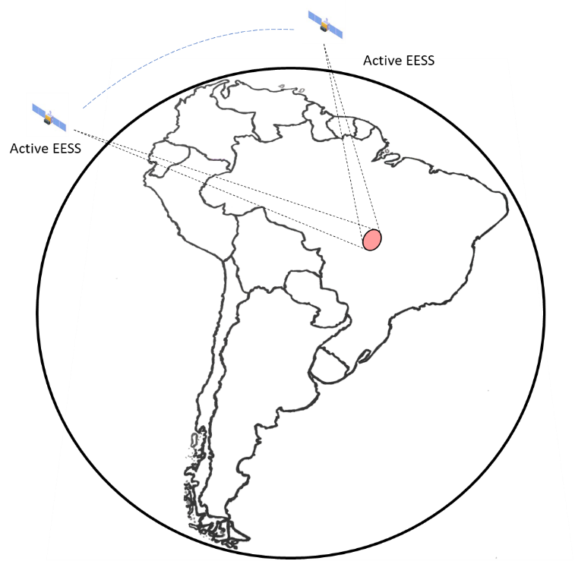

Our coexistence study scenario is presented in Fig. 5, which is considered the whole Brazil territory. In addition, the intersite distance and number of base stations are following Ra and Rb density factors for the coverage area presented in Table 5. The UE is distributed within the hotspot coverage area, with a Rayleigh distribution with scale parameter σd = 32 m for the distance between UE and BS hotspot, and a normal distribution for the azimuth between them, truncated at the ±60o range, with mean μa = 0o and standard deviation σa = 30o. The Active EESS sensor was modeled according to characteristics presented in Section 2 and we considered two cases of antenna beam angle, 18 and 500.

Regarding the calculus of the number of base stations in the whole Brazil territorial area (Sarea), we followed the Urban and Suburban density of 30 and 10 BS/km2, respectively. The Ra and Rb factors were applied as follows.

According to our study area, the number of base stations, N, to be deployed is calculated by:

In this study, we are considering the overlapping of IMT and EESS (active) in the band 10 - 10.4 GHz. In this context, we considered 4 operators, each one using 100 MHz, performing the 400 MHz of spectrum usage in co-channel. Therefore, we multiply the number of base stations NBase Stations by 4, as a result, the total number of base stations considered in our study is 816,992 hotspots, in this number will be used as NBase Stations. To reduce the computational effort, we used the segment factor methodology and our topology is presented in Fig. 5.

FIGURE 5

IMT network deployment scenario with 7 clusters of 19 cells with 3 hotspots per sector

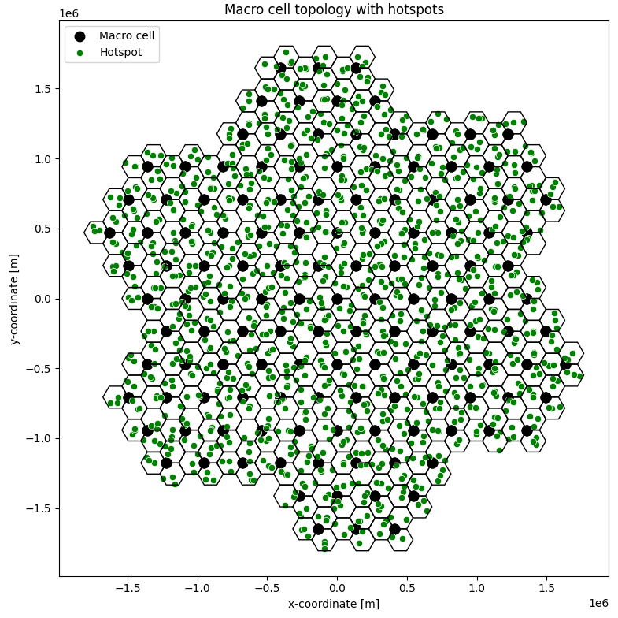

At each simulation snapshot, the BS and UE are randomly generated and uniformly distributed in a simulation scenario, according to Rec. ITU-R M.2101 (see §3.1.4, Approach No 1). The coupling loss is calculated between UE and BS, considering beamsteering limit angles in serving BS. In addition, the simulation performs the resource scheduling, power control, enabling the interference calculation between the IMT-2020 system and EESS (active) sensors. The simulations were done with 10 000 snapshots. The segment factor (S) can be assessed as follow:

Table 5 presents the simulation parameters used in our simulation.

TABLE 5

Simulation parameters

| Parameter | Value |
| --- | --- |
|  | 30% (Urban area) and 10 % (Suburban area) |
|  | 7 % (Urban area) and 3% (Suburban area) |
|  | 1 % |
|  | 8,510,343.358 |
| ISD [km] | 271,820 |
|  | 816,992 |
|  | 1,197 |
| S | 682 |

Furthermore, our study considered the whole visibility area and the spot beam area summed. For the spot beam area, we performed the hotspot distribution in a spot area of 25 km2, considering 4 operators. The total of 228 hotspots were deployed in the study area to perform a separated simulation that will be used in the post processing assessment.

A sensitivity analysis was performed considering IMT antenna sidelobe suppression of 30 dB according to the methodology presented in the revision of the Brazilian contribution Document WP 5D/677. Fig. 6 reports the results of the composite IMT AAS pattern performing 30dB of sidelobe suppression based on Taylor One Parameter distribution. Table 6 presents the results in excellent agreement with our numeric sidelobe suppression calculus. We achieved a sidelobe suppression of 29.43 dB, based on the 30 dB specified. This small difference can be explained due to the discretized power per element, due to not have sufficient elements to perform a uniform distribution. The blue curve represents the standard AAS model based on Rec. ITU-R M.2101 and the orange curve are results of our antenna pattern approach based on Taylor One Parameter distribution aimed at sidelobe suppression in vertical antenna patterns. Furthermore, it´s important to highlight that our proposed AAS model aimed at low sidelobe levels achieved a sidelobe suppression improvement of 15.87 dB with a reduction of gain of 1.08 dB and an increase of beamwidth of 3.220

Table 5

AAS 8x8 comparison 0

|  |  |  |
| --- | --- | --- |
| Parameter | Rec. ITU-R M.2101 | Our approach |
|  | 23.56 dBi | 22.48 dBi |
|  | 12.690 | 15.910 |
|  | -13.56 dB | -29.43 dB |

Figure 6

**AAS 8x8 antenna pattern comparison**  **0, horizontal and vertical.**

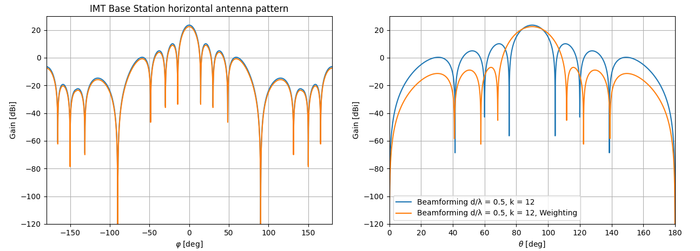

**Methodology and Results**

For the study of the interference from the IMT-2020 system into the Active EESS, one may need to assess the interference generated within and outside the spot beam, covering hundreds of square kilometres. Our study considers two simulations, one considering the satellite whole visibility and another the spot beam area. Simulating all the BSs in that area would require very high computational requirements. To overcome this problem, this study considers the simulation of a network segment composed of a smaller number of IMT stations deployed over the whole study area. The ratio between the desired number of IMT stations and the simulated number of IMT stations is defined as the segment factor . The procedure of our study methodology is listed below:

**Step-by-step**

**Step 1 - Simulation of whole satellite visibility**

Uniformly random distribution of Hot Spots within each cluster of the macro geographical area, representing a large segment of the IMT network (1,197 base stations).

**Step 2**

Generate the Active EESS system based on its characteristics, pointing the antenna beam angle towards the region of coverage.

**Step 3**

Generate the UEs and at each snapshot distribute them in the IMT Hotspot area, following the statistical distribution and link the UEs with each Hotspot, considering the maximum beamforming BS elevation angles, allocating their respective resource blocks, enabling power control, and calculate the coupling loss between IMT Hotspots and UEs.

**Step 4**

Calculate the aggregate INR and collect the results of the Active EESS stations that may suffer interference from IMT downlink and uplink at each snapshot.

**Step 5 - Simulation the satellite spot area**

Start a new simulation environment to perform a spot beam simulation. Uniformly random distribution of Hot Spots within each cluster of the spot beam geographical area, representing a segment of the IMT network (228 base stations).

**Step 6**

Generate the Active EESS system based on its characteristics, pointing the antenna beam angle towards the region of coverage.

**Step 7**

Generate the UEs and at each snapshot distribute them in the IMT Hotspot area, following the statistical distribution and link the UEs with each Hotspot, considering the maximum beamforming BS elevation angles, allocating their respective resource blocks, enabling power control, and calculate the coupling loss between IMT Hotspots and UEs.

**Step 8**

Calculate the aggregate INR and collect the results of the Active EESS stations that may suffer interference from IMT downlink and uplink at each snapshot.

**Step 9**

After the 10.000 snapshots, collect the I/N samples from downlink and uplink simulations results of the whole visibility area to perform the Segment factor, as presented in Section 3, for post-processing. Therefore, when simulating a network segment, one I/N value is collected after each snapshot. Then, to calculate the total aggregated interference from multiple network segments, another Monte Carlo-based simulation is performed. In each step of this post-processing routine, 75% of I/N samples (based on TDD factor) of the segment factor are taken off the I/N values from downlink simulation, and the other 25% are taken from uplink of the simulated network segments and summed up to obtain the total aggregated interference at the space station. The post processing considers the whole visibility area and the spot beam area results. The segment factor is used in the satellite I/N samples and at each snapshot considering the whole visibility area, 75% (based on TDD factor) of the samples of downlink and 25% of the uplink I/N spot beam results are summed to compute the aggregate I/N of the study.

The results of the simulations, as shown in Fig. 7, indicate that for the Active EESS antenna beam looking angle of 180 and 500 the achieved aggregated INR is above the SAR protection criteria for the 99% criteria. Additionally, simulations were done considering a sensitivity analysis, by applying suppression sidelobe (SSL) of 30 dB in the IMT AAS, as shown in Fig. 6. The achieved I/N for the Active EESS station decreases about 14.24 and 6.81 dB for 500 and 180 respectively. Finally, the sensitivity analysis presented an important method to mitigate possible Earth-space path interferences and for both cases, the protection criteria are still met.

FIGURE 7

IMT-Active EESS co-channel simulation results

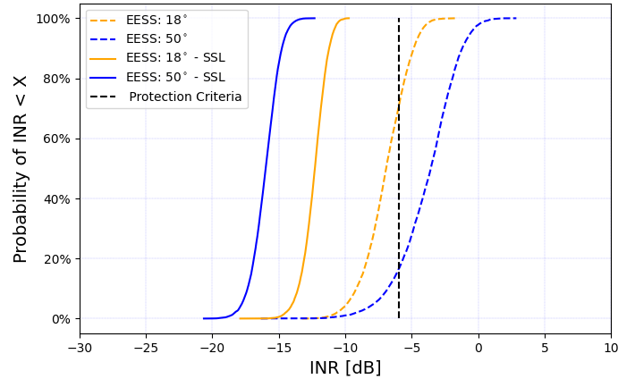

**Apportionment**

No apportionment is being considered. In the band 10 – 10.4 GHz we have EESS (active) and Radiolocation as primary services, and in some Region 2 countries, we also have Mobile and Fixed as primary services.

In the past, few companies were deploying Wi-Max point-to-multipoint solutions in Brazil, but currently, this band is not being used anymore for such systems.

Radiolocation and EESS (active) both typically use waveforms that enable processing gains, which would alleviate any harmful interference. Additionally, the results obtained for a deployment of 50 G4 radars presented in Rep. ITU-R RS.2313-0 shows that the I/N obtained for 1% of the time when the sensor is active is –19 dB, 13 dB below the protection criterion of the EESS SAR-4, these figures do not account for any EESS SAR-4 processing gain. Therefore, the potential of harmful interference from RLS emissions on SAR-4 is very low.

# 4 Summary and analysis of the results of Study

The results of this suggest that sharing between IMT and Active EESS service operating in 10-10.4 GHz (co-channel) is feasible, if mitigation measures is considered. This mitigation measure, for instance, can be AAS sidelobe suppression technique.

It was shown that decreasing the IMT emission towards Active EESS changed the sharing evaluation from unfeasible to feasible, once the EESS(active) protection criteria was met with this technique, in comparison with the standard AAS model based on Rec. ITU-R M.2101.

# 5 References

[1] Brazil territory area [Instituto Brasileiro de Geografia e Estatística - IBGE - https://www.ibge.gov.br/geociencias/organizacao-do-territorio/estrutura-territorial/15761-areas-dos-municipios.html], access in September 2021.

[2] Brazil land data [Food and Agriculture Organization of the United Nations - http://www.fao.org/countryprofiles/index/en/?iso3=BRA], access in September 2021.

_______________